22AIE204 Introduction to Networks Labsheet6

Building Network in Packet Tracer
Name: Girish S Roll No.: AM.EN.U4AIE22044

Problem 1) Write UDP client and server datagram to send messages among each other.
Server.py
import socket

SERVER_IP = "127.0.0.1"
SERVER_PORT = 12345

server_socket = socket.socket(socket.AF_INET, socket.SOCK_DGRAM)

server_socket.bind((SERVER_IP, SERVER_PORT))
print(f"Server listening on {SERVER_IP}:{SERVER_PORT}")

while True:
data, client_address = server_socket.recvfrom(1024)
print(f"Received from client: {data.decode()}")

response = input("Enter your response: ")
server_socket.sendto(response.encode(), client_address)

client.py
import socket

SERVER_IP = "127.0.0.1"
SERVER_PORT = 12345

client_socket = socket.socket(socket.AF_INET, socket.SOCK_DGRAM)

try:
while True:
message = input("Enter your message: ")
client_socket.sendto(message.encode(), (SERVER_IP, SERVER_PORT))

response, server_address = client_socket.recvfrom(1024)
print(f"Received from server: {response.decode()}")

if message.lower() == "exit":
break
finally:
client_socket.close()

Problem 2) Write TCP client and server datagram to send messages among each other.
Server.py
import socket

SERVER_IP = "127.0.0.1"
SERVER_PORT = 12345

server_socket = socket.socket(socket.AF_INET, socket.SOCK_STREAM)

server_socket.bind((SERVER_IP, SERVER_PORT))

server_socket.listen(1)
print(f"Server listening on {SERVER_IP}:{SERVER_PORT}")

client_socket, client_address = server_socket.accept()
print(f"Connection established with {client_address}")

try:
while True:
data = client_socket.recv(1024)
if not data:
break
print(f"Received from client: {data.decode()}")

response = input("Enter your response: ")
client_socket.sendall(response.encode())
finally:
client_socket.close()
server_socket.close()
print("Connection closed")

client.py
import socket

SERVER_IP = "127.0.0.1"
SERVER_PORT = 12345

client_socket = socket.socket(socket.AF_INET, socket.SOCK_STREAM)

client_socket.connect((SERVER_IP, SERVER_PORT))
print(f"Connected to server at {SERVER_IP}:{SERVER_PORT}")

try:
while True:
message = input("Enter your message: ")
client_socket.sendall(message.encode())

response = client_socket.recv(1024)
print(f"Received from server: {response.decode()}")

if message.lower() == "exit":
break
finally:
client_socket.close()
print("Connection closed")

Problem 3)
After login to netacad.com, download latest version of Packet Tracer. Now open the Labsheet5scenario.pkt file.
Answer the following questions:
- What is the subnet mask of CAD Lab subnet.
The subnet mask of CAD subnet is 255.255.255.0
The subnet mask of amritavidya.edu subnet is 255.255.255.252
The subnet mask of amrita.edu subnet is 255.255.255.252
- What is the IP address of DHCP server and DNS server?
The IP address of DHCP server is 192.168.0.2
The IP address of DNS server is 192.168.0.5
- Open amrita.edu from the browser of PC0, PC1 or PC2.
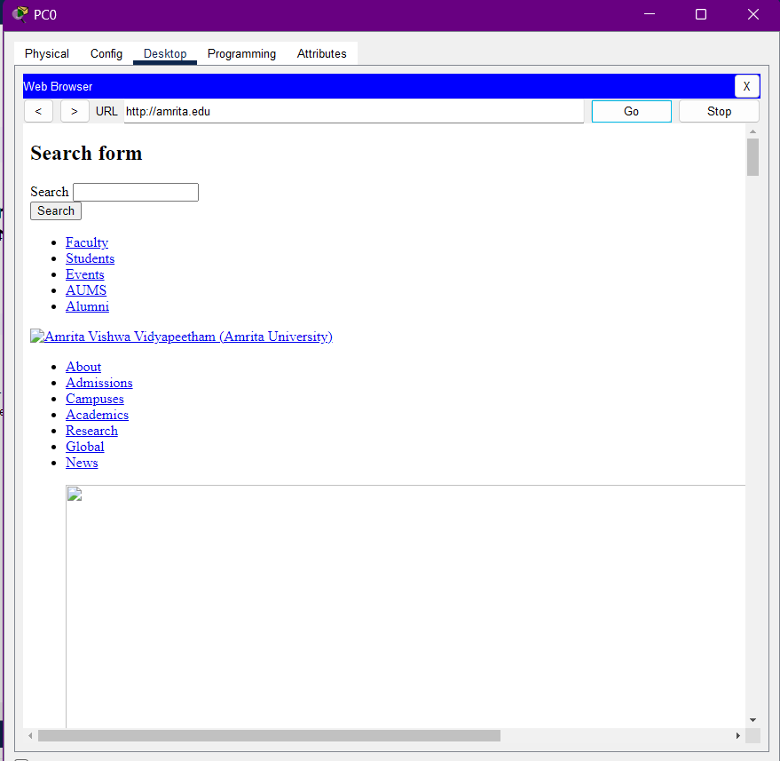
- How many subnets are there?
There are 3 subnets.
The CAD subnet
The amritavidya.edu subnet
The amrita.edu subnet
- Does the DHCP and DNS server belongs to the same subnet/network of PC1 or PC2.
No, the PC1 and PC2 belong to a different subnet called CAD subnet with subnet mask of 255.255.255.0. while the DHCP server and DNS server belongs to the subnet called amritavidya.edu subnet with subnet mask of 255.255.255.252.

